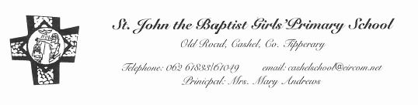

St. John the Baptist Girls' School Junior Infant Book List
2017/2018

Readers on Book Rental Scheme €8.oo
Copies, colouring pencils etc. €10.00
Total €18 payable in June

English: Pre-Reading Activity Book Reading Zone - Folens
2 x Plastic Envelope Folders A4

Handwriting: Write this Way Book I (green cover) Folens. Just Handwriting (Pre-cursive handwriting Programme) - Junior Infants - Educate.ie
Religion: Grow in Love – Junior Infants Primary 1.

Maths: Planet Maths - Junior Infants - Folens

Visual Arts: Large size Pritt stick

€20 to cover cost of art materials, photocopying.

Please put money in a sealed envelope with child's name & give to the teacher in September.

Please label everything clearly with your child's name.

